Develop a VB Project to display the student information using ADO with oracle

From design:

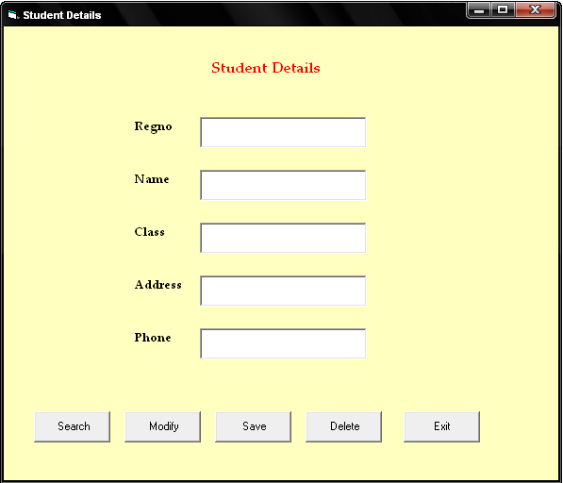

Properties:

Controls | Name | Caption
Text1 | Trno
Text2 | Tname
Text3 | Tclass
Text4 | Tad
Text5 | Tphno
Command1 | Cmdsearch | Search
Command2 | Cmddelete | Delete
Command3 | Cmdmodify | Modify
Command4 | Cmdsave | Save
Command5 | Cmdend | exit

15.Student Details
Aim:
To develop a VB Project to display the student information using ADO with oracle

Coding:
Dim db As ADODB.Connection
Dim rs As ADODB.Recordset
Dim rno As String

Private Sub cmddelete_Click()
Dim i As Integer
i = MsgBox("Do you want to delete?", vbYesNo)
If i = vbYes Then

While Not rs.EOF
If rs.Fields(0) = Val(trno) Then
rs.Delete
GoTo out
End If
rs.MoveNext
Wend
out:

If rs.EOF Then
rs.MoveFirst
Else
rs.MoveNext
End If

Call view
MsgBox "Deleted"
End If
End Sub

Private Sub cmdexit_Click()
End
End Sub

Private Sub cmdmodify_Click()
rs.Find "rno=" & Val(trno)
rs.Requery
End Sub

Private Sub cmdsave_Click()
rs.Fields(0) = Val(trno)
rs.Fields(1) = tname
rs.Fields(2) = tclass
rs.Fields(3) = tadd
rs.Fields(4) = tphno
rs.Update
MsgBox "Record Stored"
End Sub

Private Sub cmdsearch_Click()
rno = InputBox("Enter the rno to search:")
f% = 0
rs.MoveFirst
While Not rs.EOF
If rs.Fields(0) = rno Then
Call view
f% = 1
GoTo out
End If
rs.MoveNext
Wend
If f% = 0 Then
MsgBox "Record not found"
End If
out:
End Sub

Private Sub Form_Load()
Set db = New ADODB.Connection
Set rs = New ADODB.Recordset
db.Open ("Provider=OraOLEDB.Oracle.1;Password=tiger;Persist Security Info=True;User ID=scott")
rs.CursorType = adOpenDynamic
rs.LockType = adLockOptimistic
rs.Open "select * from stud", db, adOpenDynamic, adLockPessimistic
Call view
End Sub

Private Sub view()
If rs.EOF Then
rs.MoveFirst
End If
If rs.BOF Then
rs.MoveLast
End If
trno = rs.Fields(0)
tname = rs.Fields(1)
tclass = rs.Fields(2)
tadd = rs.Fields(3)
tphno = rs.Fields(4)
End Sub

Output:

